CVEditor
Release Report
<Fill here the Group Name>
<Fill here the Group Members, Name and AM>

Versions History
Date | Version | Description | Author

Introduction
This document provides information concerning the 1 release of the project.

Purpose
The preparation of a Curriculum Vitae (a.k.a. resume) is a very important task for everyone who is looking for a job or an internship. The main goal of the project is to develop CVEditor, an application that makes this task easier, especially for young inexperienced people such as graduate and undergraduate students. At a glance, CVEditor shall allow a user to prepare a new CV based on well known templates (chronological, functional, combination), change the structure of an existing CV by switching between these templates, generate actual CV documents in well known formats (Latex, Microsoft Word), trace changes between different CV versions and so on.

Document Structure
The rest of this document is structured as follows. Section 2 specifies the acceptance tests that have been employed for this release of the project. Section 3 specifies the main design concepts for this release of the project.

Acceptance Tests
<For the user stories included in this releases specify below corresponding tests using a typical tabular form.>

Tests for User Story US2
Test ID | 1
Class | ListableForm
Test Name | Correct chronological order
Description | Checks if values inserted correctly when the chronological order is correct
Test Data | One Item with date = 2017-10-10  One Item with date = 2017-11-11  One date (2018-10-10) for checking
Expected result | The method checkDate should return true

Test ID | 2
Class | ListableForm
Test Name | Wrong chronological order
Description | Checks if values are not inserted when the chronological order is not correct
Test Data | One Item with date = 2017-10-10  One Item with date = 2017-11-11  One date (2015-10-10) for checking
Expected result | The method checkDate should return false

Test ID | 3
Class | ListableForm
Test Name | First date
Description | Checks if the first date is correctly inserted
Test Data | An empty list of Items  One date (2015-10-10) for checking
Expected result | The method checkDate should return true

Design

Architecture

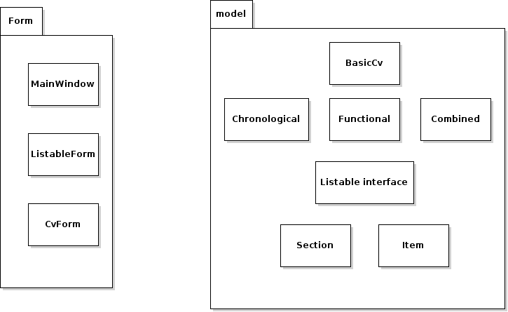

Design

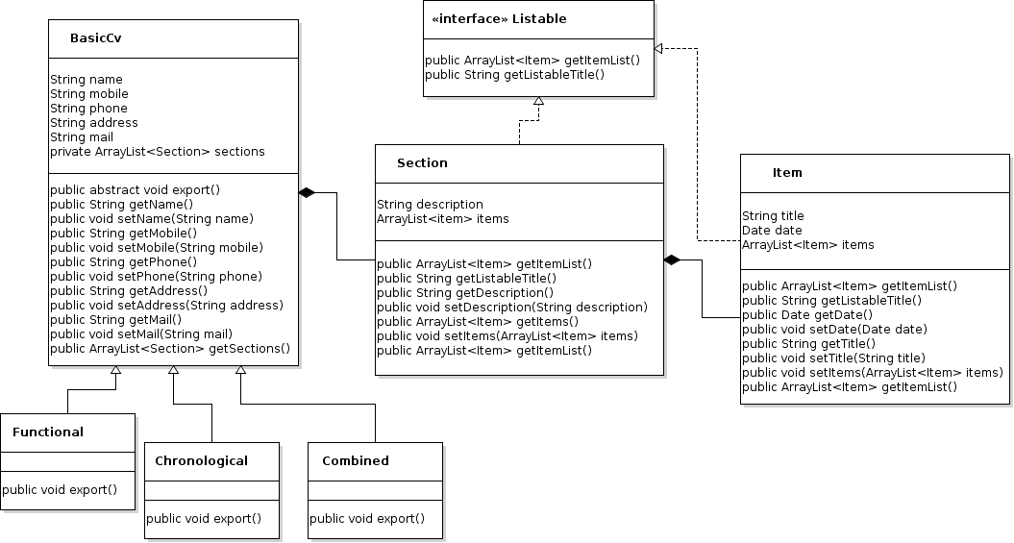

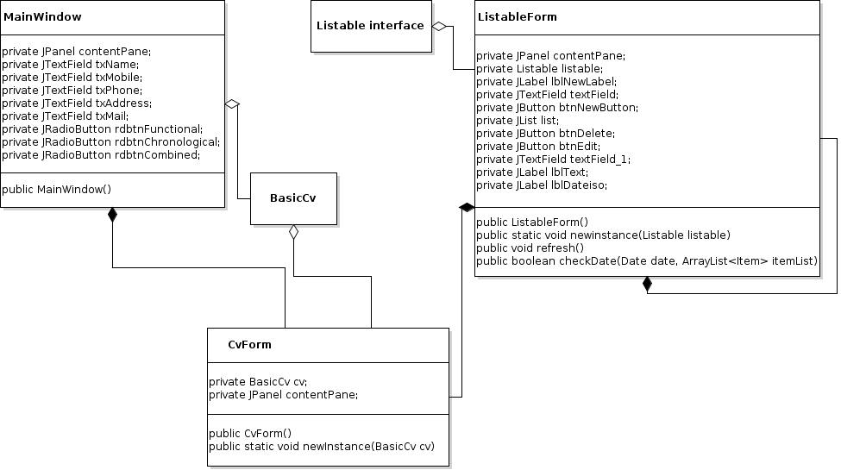

Class Name: BasicCv
Responsibilities:  - Represents the cv information | Collaborations:  - Section

Class Name: Item
Responsibilities:  - Represents information about each item of the section | Collaborations:  - Listable

Class Name: Functional
Responsibilities:  - Extends BasicCv  - Knows how to be exported in Functional form | Collaborations:  - BasicCv  - Section  - Item

Class Name: Chronological
Responsibilities:  - Extends BasicCv  - Knows how to be exported in Chronological form | Collaborations:  - BasicCv  - Section  - Item

Class Name: Combined
Responsibilities:  - Extends BasicCv  - Knows how to be exported in Combined form | Collaborations:  - BasicCv  - Section  - Item

Class Name: MainWindow
Responsibilities:  - Graphical user interface  - Allows user to give basic information about the cv  - Allow user to select the cv format | Collaborations:  - BasicCv  - Functional  - Chronological  - Combined

Class Name: CvForm
Responsibilities:  - Graphical user interface  - Allows user to select sections for edit | Collaborations:  - Listable  - Section  - item

Class Name: ListableForm
Responsibilities:  - Graphical user interface  - Allows user to add items to section  - Allows user to delete items from section  - Allows user to edit item from sections | Collaborations:  - Listable  - Item

Class Name: Listable
Responsibilities:  - Interface | Collaborations:

Implementation
A printed copy of the source code (including the implementation of (1) classes and (2) tests) of this release is attached to the release report. The source code is further provided in a CD/DVD/USB-stick.

